**Andres Alexander Manuel Mendoza-Bernardo Guerra**

**N01708732**

Find a website with a problematic user interface / lacks usability and submit your answers in word document for the following 5 questions: (This lab is worth 2%)

1. **URL of the site evaluating**

<https://www.lamolina.edu.pe/>

I chose the main page

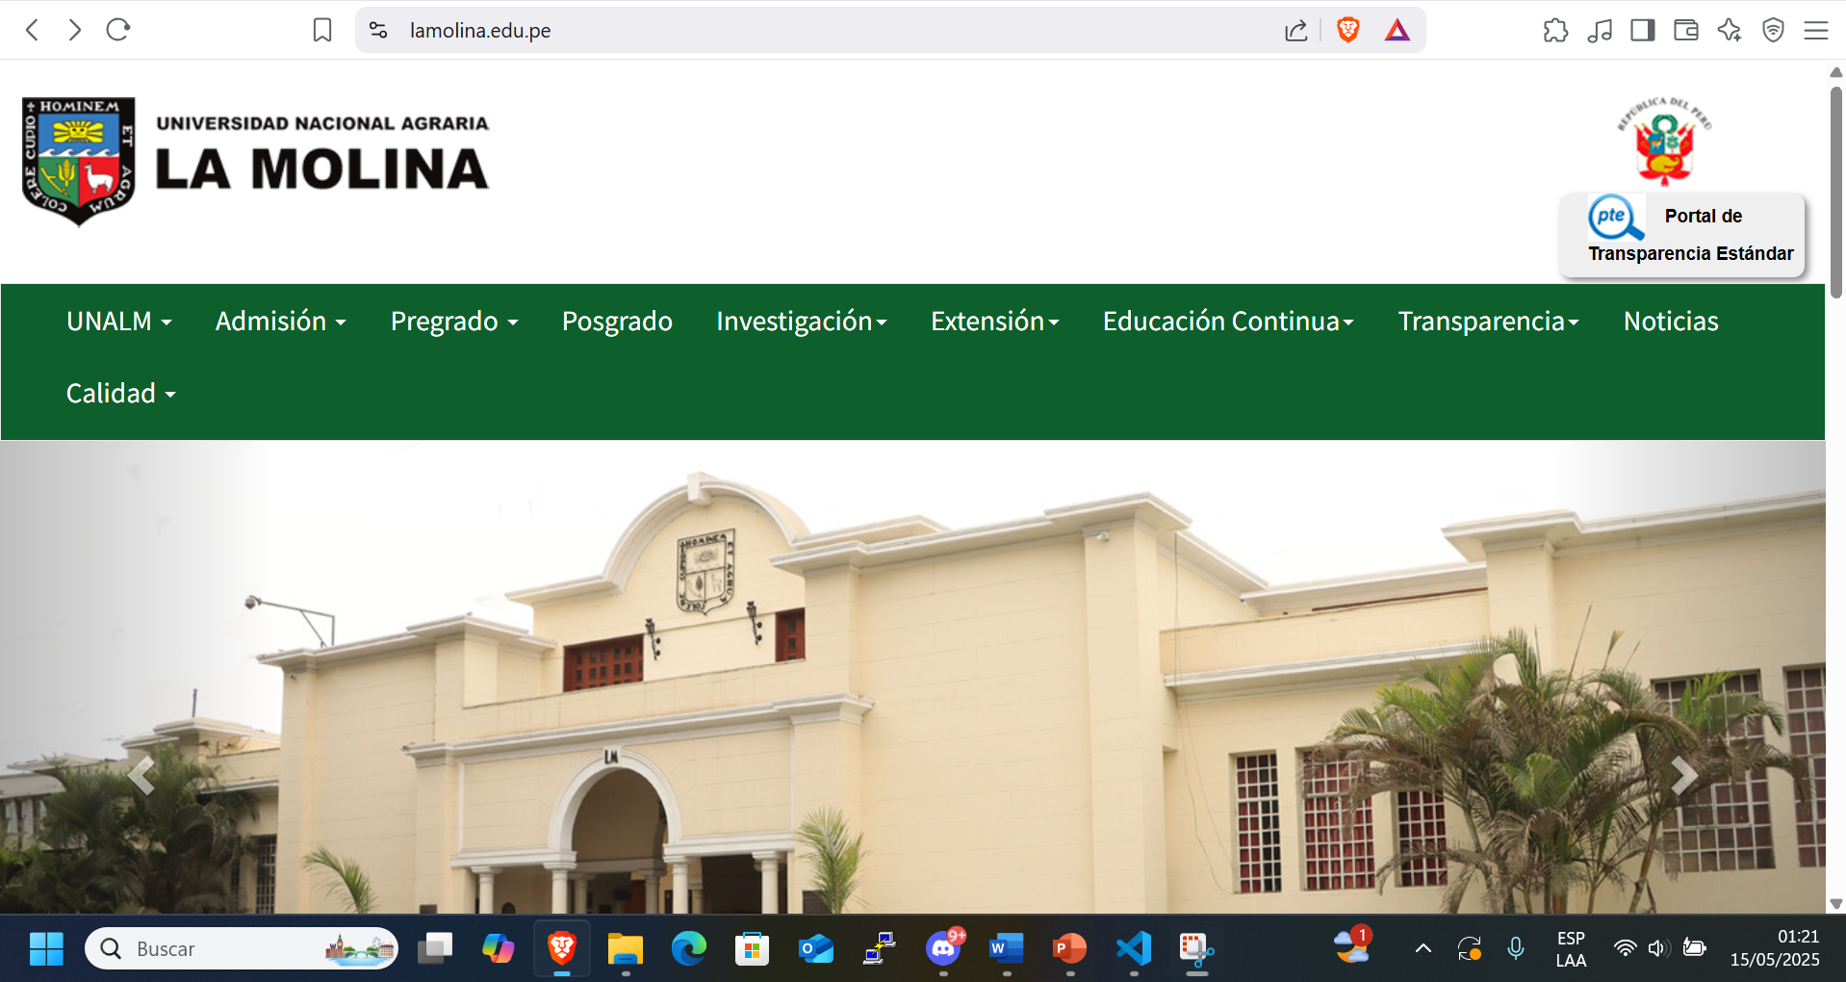

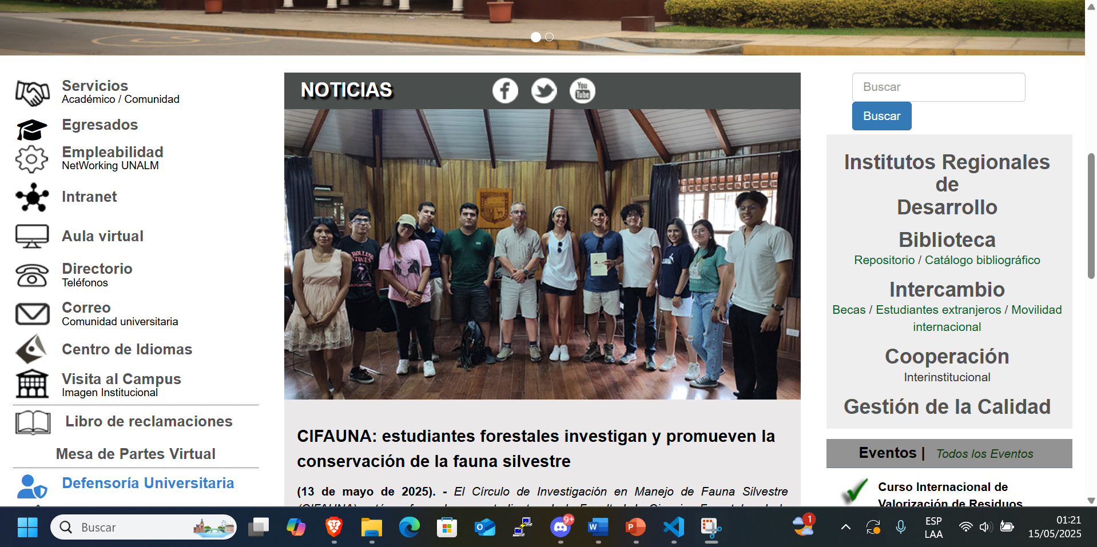

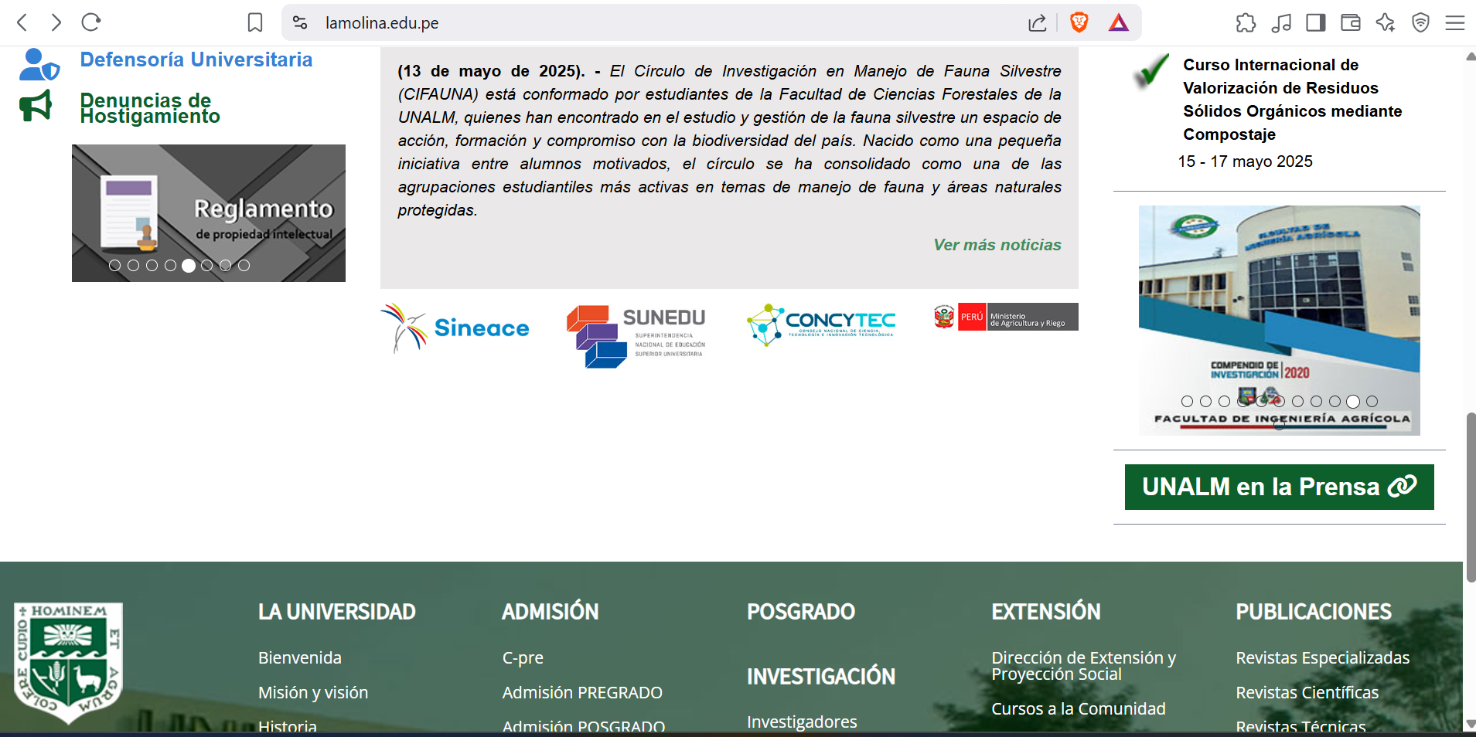

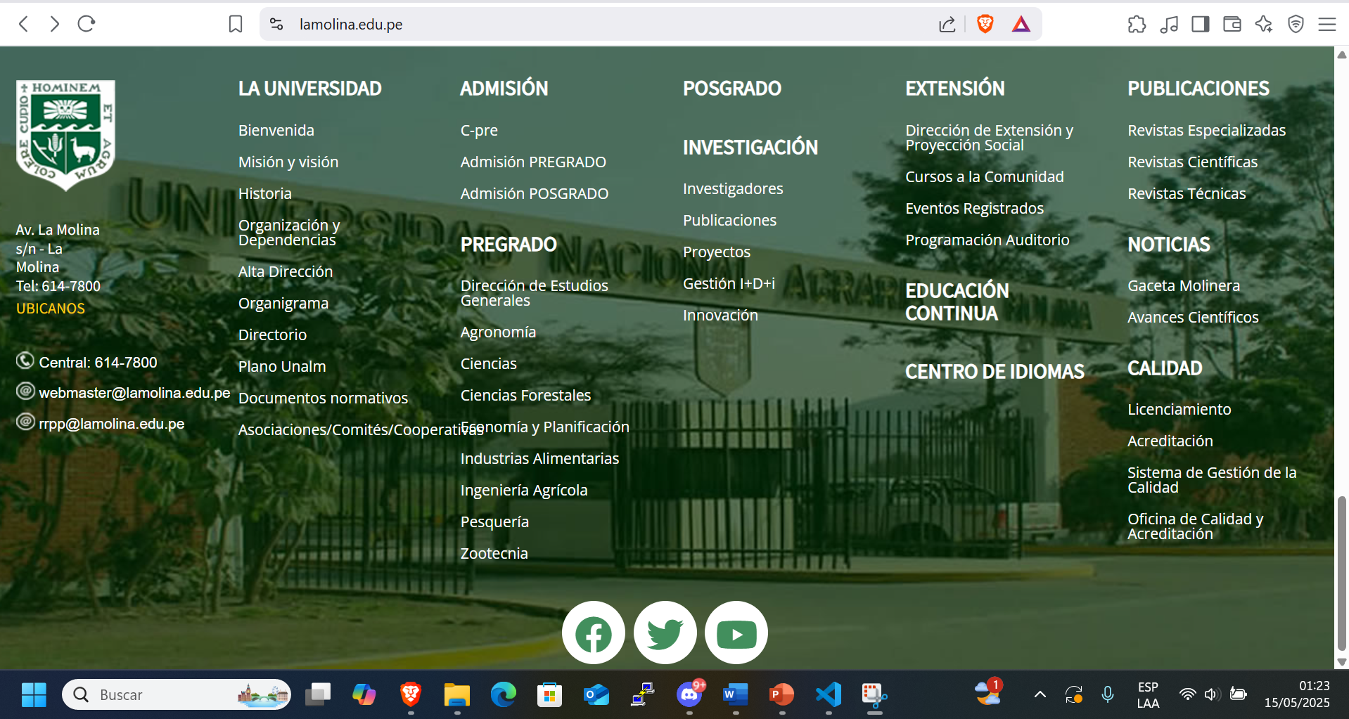

1. **Targeted audience**

Students at the Peruvian university “National Agrarian University of La Molina “or potential students.

1. **Things you like**

* The chosen images for the social media shortcuts will change colors when you pass your cursor over them.
* The lateral navigation bar specifies and defines correctly each of the categories in an understandable way, making navigation more friendly for users.

1. **Thing you don’t like**

* Zoom doesn’t work correctly, and the web page gets distorted. Basically, if you try to zoom out, only the words get smaller, and many of the images remain the same.
* There’s no contrast between the swapper dots and the images. Most of the texts of the images and the swapper dots are difficult to differentiate one from the other.
* The footer text overlaps. One of the links called “Asociaciones/Comités/Cooperativas” gets overlapped with “Economia y Planificacion” making possible to click the incorrect one.
* The navigation bar opens a new tab instead of refreshing the current one. For example, when you click the category “Postgrado” it will open a new tab, and then if you attempt to return to the main page, it will open it in another tab, and you end up with three tabs.
* Some of the quick access links don’t work, like “Biblioteca” on the right side of the website.
* The footer looks overcrowded with links. There are too many categories on the footer, making it overwhelming for the user.
* The search bar should be above the fold. Usually, a search bar’s purpose is to help the user search for keywords on the web page that are related to the idea he is looking for. In this case, since the search bar is under the fold, the user will not have direct and quick access to it, and he will need to take an extra step to search for his idea.
* Social media shortcuts are different; the Twitter logo at the bottom has a different link than the one at the top and logs you out from your Twitter(“X”) account.
* The web page isn’t mobile friendly. In some devices that I used to open the website; the page will have some new overlapping.

1. **Suggestion for improvement**

* Fix the resize of the images depending on the percentage of the zoom.
* Make the swapper dots be under the images instead of being inside them or just edit the images to have a clear space for the swapper dots to be placed.
* Avoid long words for the footer links to not have them overlap.
* Make the navigation bar categories refresh the main tab showing the new web page instead of opening a new one.
* Change the link of “Biblioteca” to one that works or simply fix the website it’s trying to send us to.
* Create subcategories inside the web pages of the categories displayed on the footer, reducing the number of categories displayed on the footer of the main page.
* Locate the search bar above the fold for the users to search their ideas more easily.
* Change the social media link for Twitter at the bottom of the website to a functional one that will redirect users to the university’s Twitter site.
* Make the website adjust itself depending on which device the user is using to access it.